1) write a c progam to calculate sum of elements in an array ?

Program :-

#include<stdio.h>
int main()
{
int arr[100], size, i, sum = 0;
printf("Enter array size\n");
scanf("%d",&size);
printf("Enter array elements\n");
for(i = 0; i < size; i++)
scanf("%d",&arr[i]);
for(i = 0; i < size; i++)
sum = sum + arr[i];
printf("Sum of the array = %d\n",sum);
return 0;
}

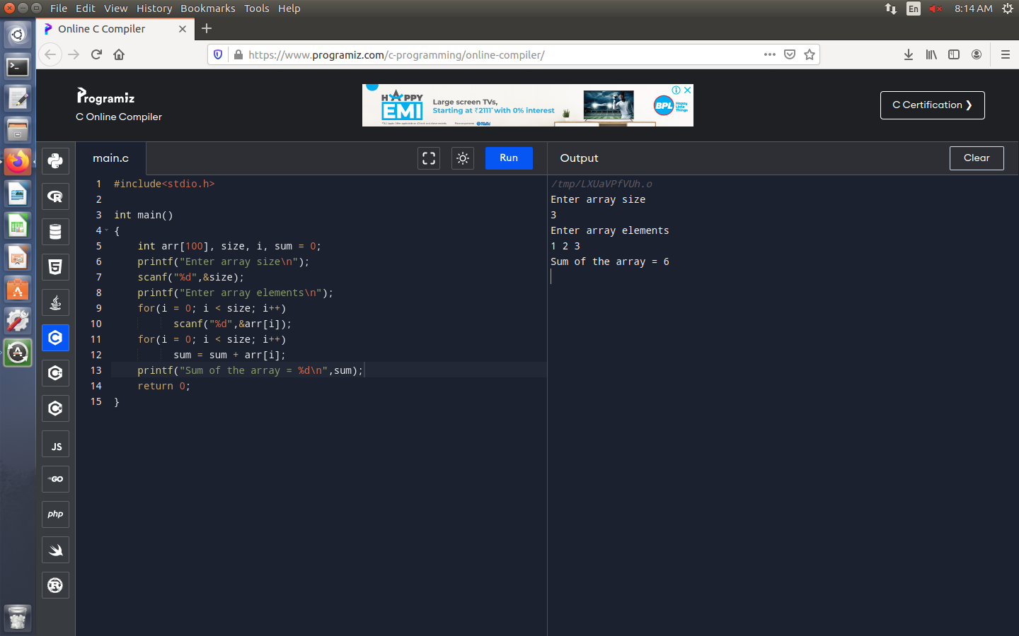

2) write a c program to merge two arrays?

PROGRAM :-

#include <stdio.h>
int main(){
int arr1size = 5, arr2size = 5, arr_resultsize, i, j;
int a[5] = { 1, 2, 3, 4, 5 };
int b[5] = { 6, 7, 8, 9, 10 };
arr_resultsize = arr1size + arr2size;
int c[arr_resultsize];
for (i = 0; i < arr1size; i++) {
c[i] = a[i];}
for (i = 0, j = arr1size;
j < arr_resultsize && i < arr2size; i++, j++) {
c[j] = b[i];}
for (i = 0; i < arr_resultsize; i++) {
printf("%d ", c[i]);}
return 0;}
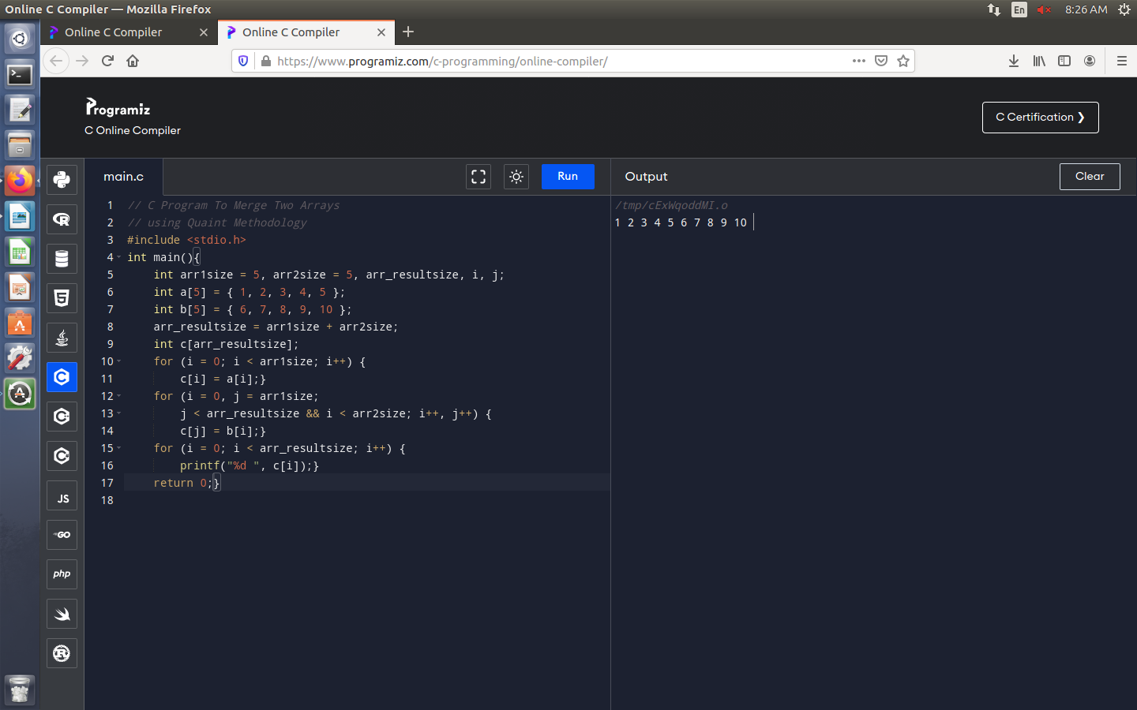

3) write a c program to perform insertion deletion of elements in the middle in an array ?

PROGRAM:-

4) write a c program to reverse a string ?

PROGRAM :-

#include <stdio.h>
int main() {
char string1[100]="malayalam", reversed_string[100];
int i, j, count = 0;
printf("\n Given String = %s", string1);
while (string1[count] != '\0') {
count++;
}
j = count - 1;
for (i = 0; i < count; i++) {
reversed_string[i] = string1[j];
j--;
}
printf("\n Reversed String = %s", reversed_string);
}

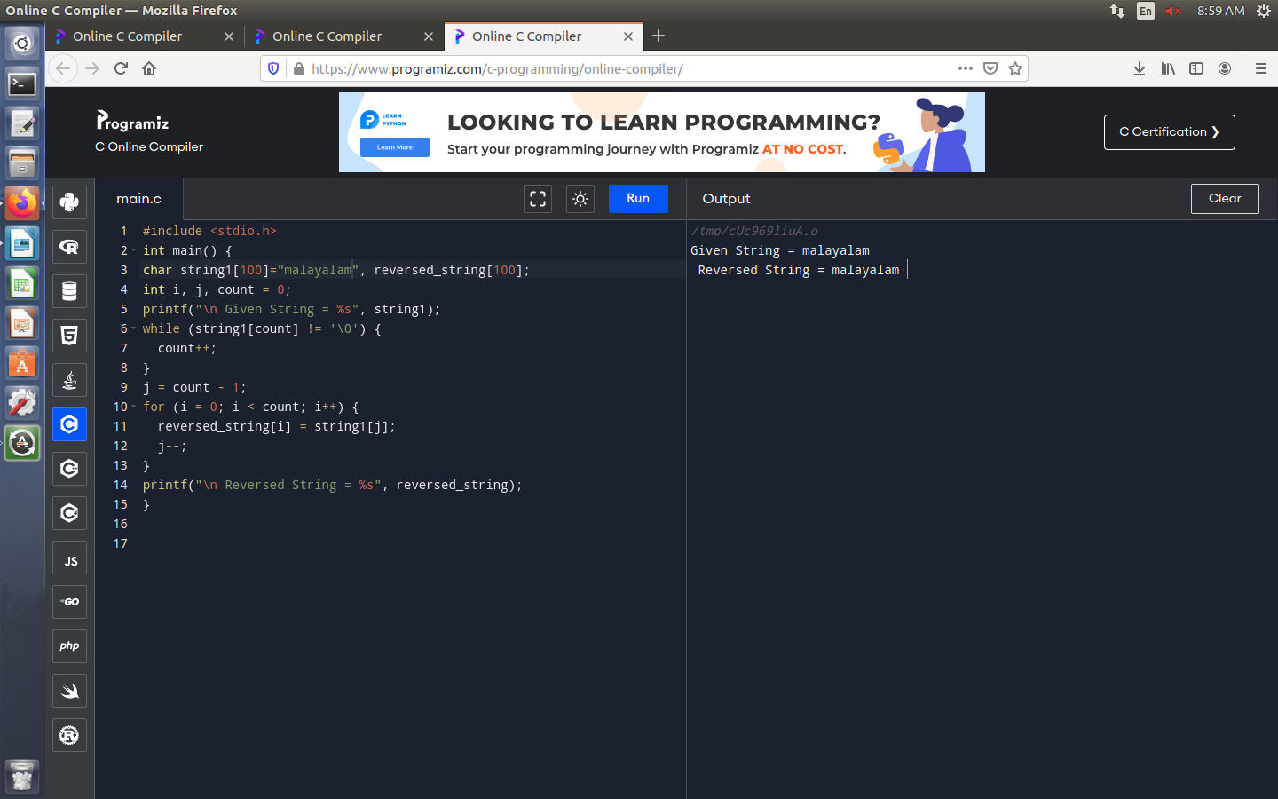

5) write a c program to check the given string is palindrome (or) not ?

PROGRAM :-

#include <stdio.h>
#include <string.h>
int main()
{
char str[] = { "malayalam" };
int l = 0;
int h = strlen(str) - 1;
while (h > l) {
if (str[l++] != str[h--]) {
printf("%s is not a palindrome\n", str);
return 0;
}
}
printf("%s is a palindrome\n", str);
return 0;
}

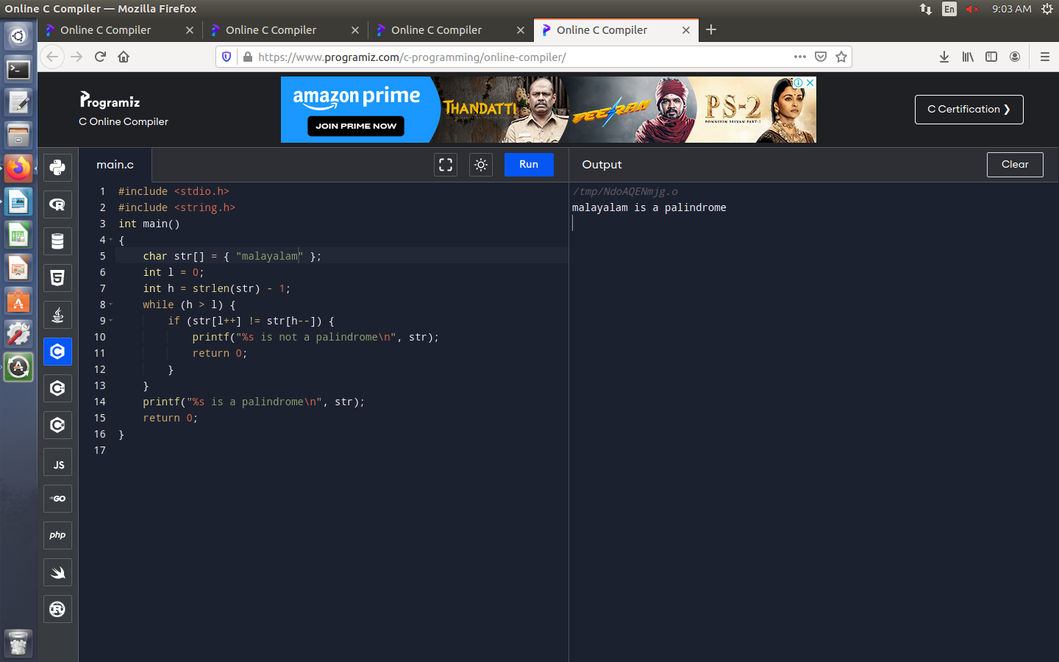
6) write a c program to search a particular characters in a string ?

PROGRAM :-

7) write a c program to count number of times a, e, i, o, u present in a given string ?

PROGRAM :-

#include <stdio.h>
int main()
{
int c = 0, count = 0;
char s[1000];
printf("Input a string\n");
gets(s);
while (s[c] != '\0') {
if (s[c] == 'a' || s[c] == 'A' || s[c] == 'e' || s[c] == 'E' || s[c] == 'i' || s[c] == 'I' || s[c] =='o' || s[c]=='O' || s[c] == 'u' || s[c] == 'U')
count++;
c++;
}
printf("Number of vowels in the string: %d", count);
return 0;
}

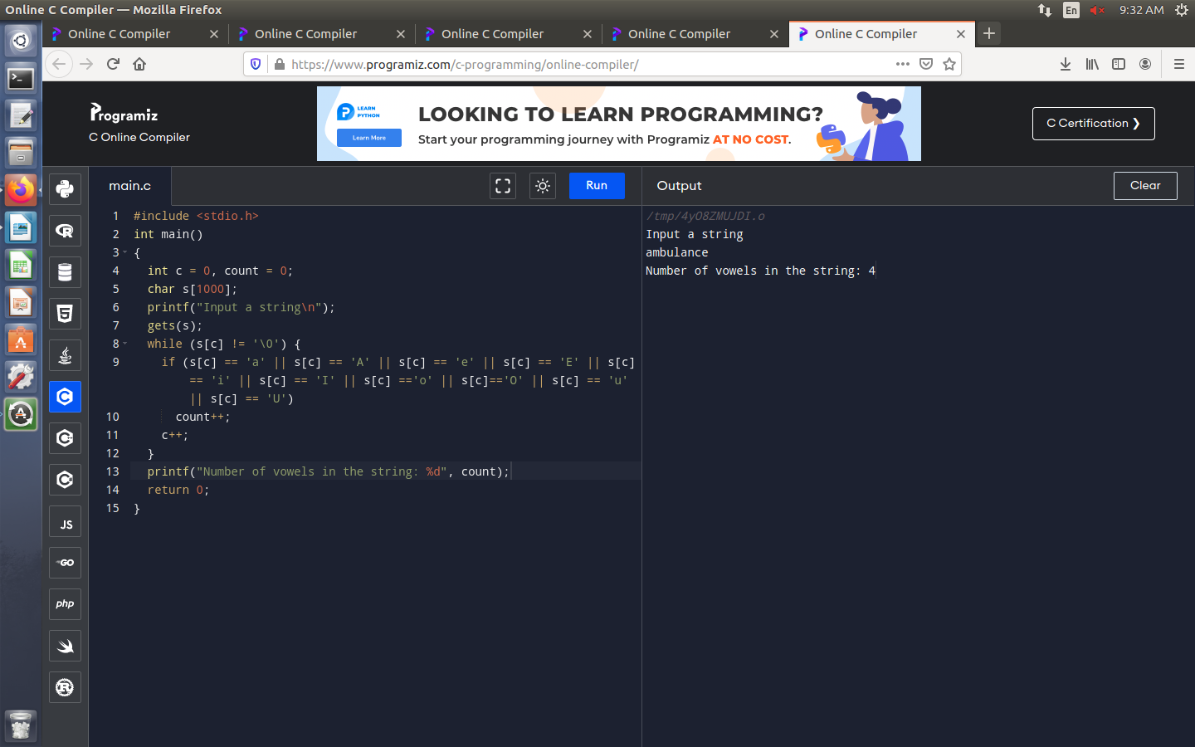

8) write a c program to perform matrix multiplication ?

PROGRAM :-

